BLUE PRINT DIRECT MAIL DELIVERY GUIDELINES 2023

Delivery Address: (All drivers to park at rear of premises and ring bell for attention)
Unit 11
Hampton Lovett Industrial Estate
Wassage Way
Droitwich
Worcestershire
WR9 0NX

Tel: 01905 621 118

DELIVERIES ACCEPTED FROM 08.00 – 17:30

DELIVERIES MUST BE BOOKED IN 24 HOURS IN ADVANCE – TELEPHONE ORDERS WILL NOT BE ACCEPTED

PLEASE EMAIL adrian.baker@bpdm.uk, jon.brown@bpdm.uk or philip.morris@bpdm.uk TO BOOK IN.

I: DELIVERIES

- All deliveries are signed for as ‘unchecked’. We cannot therefore accept responsibility for incorrect deliveries.

- Stock will be booked in at the quantity listed on the paperwork accompanying the goods.

- Deliveries will not be weighed.

- We will require a minimum of 48 hours’ notice if any or all mailing components are expected to arrive later than scheduled.

- Administration of pack contents will incur a one-off charge of £25 to cover correspondence and labour.

- It is the responsibility of the client to ensure that all items are delivered in line with the agreed schedule.

- All components must be clearly labelled with either job reference or product description and box quantity, with a sample copy (or photocopy) also attached.

- We must receive a delivery schedule at least 3 working days in advance, to include the following:
Supplier name
Delivery date
Expected quantity

- Any part deliveries must be agreed in writing and a detailed schedule provided by the client and agreed by BPDM. For mailing cells up to 100,000 all items must be delivered in one consignment unless agreed otherwise by BPDM at least 72 hours in advance. Only when the entire cell has been received and audited against Mailsort report totals will mailing commence.

- We will audit the first three and last three Mailsort codes prior to mailing – split Mailsort codes will not be accepted. Items must be delivered in to Blue Print Direct Mail at least eight working hours prior to commencement of enclosing in order for them to be audited for quality and machinability.

- All deliveries must be accompanied by a delivery note to include the following:
Booking reference
Component code/description
Job title/campaign name
Number of boxes
Number of pallets
Total quantity
Box Quantity
Sequence numbers of items contained on each pallet delivered

II: PALLETISED ITEMS

- All stationery to be supplied on pallets. If we have to restack pallets due to issues in transit the charge will be £30 per pallet.

- Pallets should be four-way entry, 1000mm x 1200mm or 800mm x 1200mm.

- Pallets must be of sound build quality and, along with contents, must not exceed 1300mm in height and/or 1500kg in weight.

- Pallets must be clearly identifiable by job name or reference with pallet quantity clearly labelled.

- Pallets and their contents must be securely shrink wrapped and bound. For reasons of Health and Safety we cannot accept goods bound with metal banding.

- Damaged pallets will not be accepted. We may also reject damp or dirty pallets and palletised items delivered at times contrary to agreed schedule.

- Only one version of any component per pallet, unless by prior arrangement.

Please refer to Section V: ‘CONTINUOUS STATIONERY REELS’ on page 3 for reel-specific pallet delivery instructions.

III: STATIONERY LABELLING AND PRESENTATION

- All items must be boxed. Maximum box weight not to exceed 11kgs.

- All boxes are to be clearly labelled with job name or reference and quantity.

- Goods will be rejected if they are damaged, damp or dirty.

- Items should be supplied in a uniform direction. If this is not possible we will accept turned items provided that the height of each turned bundle is no less than 100mm.

- Each bundle to contain a uniform number of copies.

IV: SEQUENCED ITEMS

- Sequenced items to be boxed with addresses face-up and running high-to-low or low-to-high. Format to be maintained throughout the cell.

- Box contents to be sequentially numbered with first and last sequence number clearly labelled on box.

- Boxes to be numbered, i.e. Box 1 of 10, Box 2 of 10, Box 3 of 10…….…

- Sequenced items supplied on pallets to be in Mailsort/run sequence.

- Re-ordering of sequential items on pallets will be charged at a rate of £30 per pallet.

- Items not supplied in Mailsort/sequence order will be rejected. Items will have to be collected by the customer for sortation or an on-site visit arranged.

V: CONTINUOUS STATIONERY REELS

- All supplied reels must be fit for purpose. Reels will be rejected if they are:
Dirty or damp
Damaged or crushed at reel edges

- Each reel must bear an identification label detailing the job name/reference number and reel quantity. The quantity must reflect the total number of forms on each reel NOT the number of cut-offs.

- Reels should be secured in place via triangular chocks and bound to a pallet via two straps passed over the top of the reel, with a third passing through the reel core (see Fig. 1 and Fig. 2 below). For reasons of Health and Safety WE CANNOT ACCEPT REELS BOUND WITH METAL BANDING.

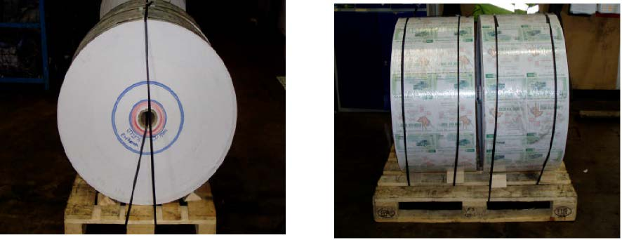
Fig. 1 Fig. 2

- All reels to be labelled with A4 labels, with job details clearly marked on the section of reel nearest the reel core (see Fig. 3 below).

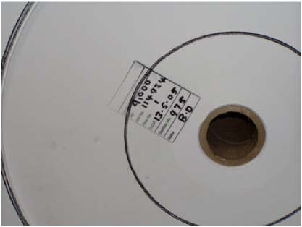
Fig. 3

Reels to be supplied with 76mm cores, with contents face-up and head-leading (the ‘head’ being the top of the sheet). 8.5 inch reels should be supplied face-up, left-leading so that the bottom of the sheet runs alongside the left-hand sprockets (Continuous stationary to be provided with sprockets).
- .

- Splicing and waste material within the reel must be flagged and clearly marked on the outside of the reel.

- Reels to be marked numerically in production sequence order and palletised accordingly.

- Reels to be supplied two per pallet, with individual reel diameters not exceeding 1200mm.

Please refer to Section II: ‘PALLETISED ITEMS’ on page 2 for general pallet delivery instructions.

VI: FLAT SHEETS FOR LASER PERSONALISATION

- All supplied sheets must be fit for purpose.

- Pre-printed sheets must be supplied the same way up and in a uniform direction.

- Sheets will be rejected if they:
Are dirty or damp
Have been poorly or incorrectly finished
Are curled or crushed
Are setting-off
Colour is not consistent throughout

- File copies should be clearly labelled

- Supplied sheets must have a minimum weight of 100gsm, unless by prior arrangement. We recommend sending paper samples in advance so we can assess their suitability for overprinting.

- To ensure maximum efficiency, stock for lasering must not be supplied as single sheets. For example, A5 cards should be supplied 4-up on A3 (or SRA3 if they have a bleed margin)

- Items intended for offline ink-jetting, such as one-piece mailers and postcards, should be supplied on porous or uncoated stock. We use quick-drying, non-solvent inks which will not dry on porous or coated material. This will only become apparent once the job starts to run. If in doubt, please contact BPDM on 01905 621118.

PACKAGING

Please refer to Section II: ‘PALLETISED GOODS’ and Section III: ‘STATIONERY LABELLING AND PRESENTATION’, both on page 2.

VII: ENVELOPES

The following specification applies to both envelopes and their contents when intended for mechanical enclosure:

- All envelopes should be supplied boxed with flaps down. They should be the same way up and facing in a uniform direction.

- Envelopes intended for machine enclosure should be gummed. ‘Peal & Seal’ or similar envelopes will not be accepted.

- Envelope flap glue strips should be at least 10mm in depth and should start and finish within 25mm of the envelope edges in order to meet CBC / OCR regulations. For this reason we would recommend supplying envelopes with a straight flap and outside seams.

- There must be a 7mm gap between the enclosed item and the envelope edge on both left and right-hand sides. (see Fig. 1 overleaf)

- There must be a 10mm gap between the top edge of the enclosed item and the flap edge of the envelope. (see Fig. 2 overleaf)

- All relevant customer information (name address, mailmark barcode…etc.) should be positioned on the enclosed item so as to be clearly visible within the envelope window, with consideration given to movement of the item within the envelope. We would recommend a minimum window size of 50mm x 90mm in order to meet CBC specification.

Failure to meet this criteria may result in mail being rejected by the carrier or a loss of postal discounts.

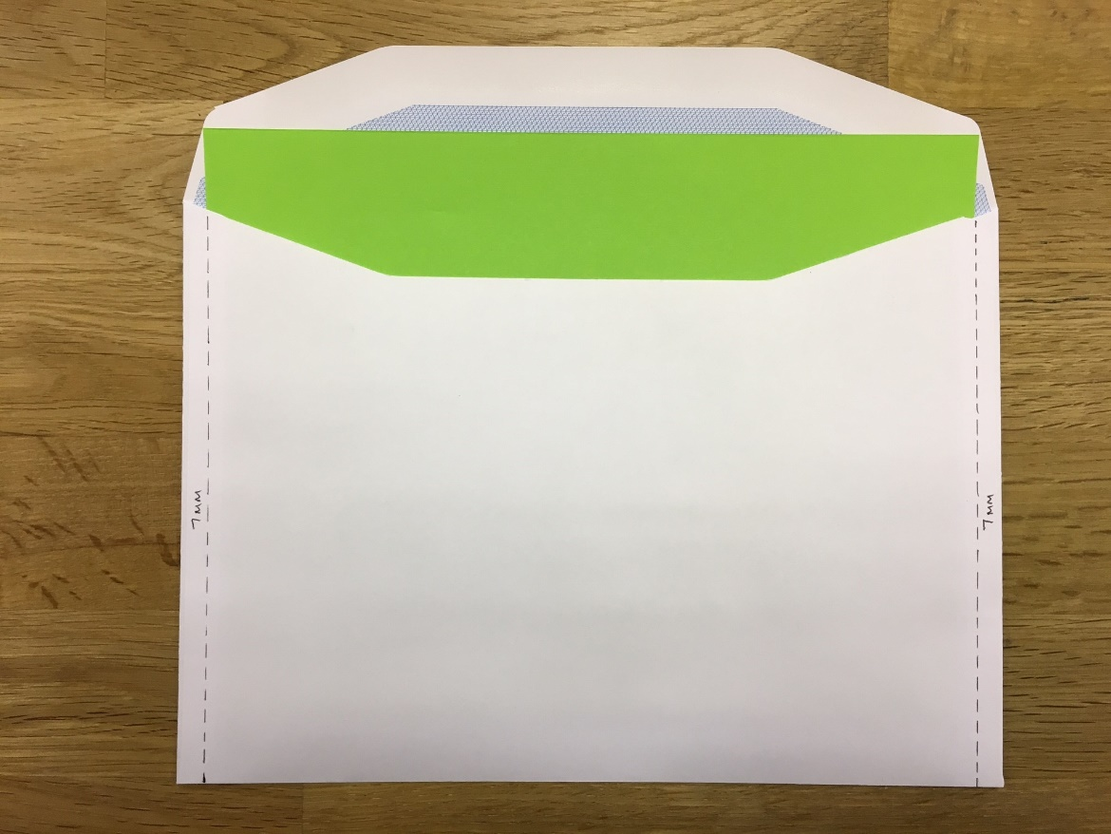
Fig 1.

Raffle Tickets

- All Raffle tickets to be supplied face up in a uniform direction The tickets to be presented in piles with the lowest number book at the bottom of a pile .

- All items must be boxed. Maximum box weight not to exceed 11kgs.

- All boxes are to be clearly labelled with job name and number range of books contained within.

- Goods will be rejected if they are damaged, damp or dirty.
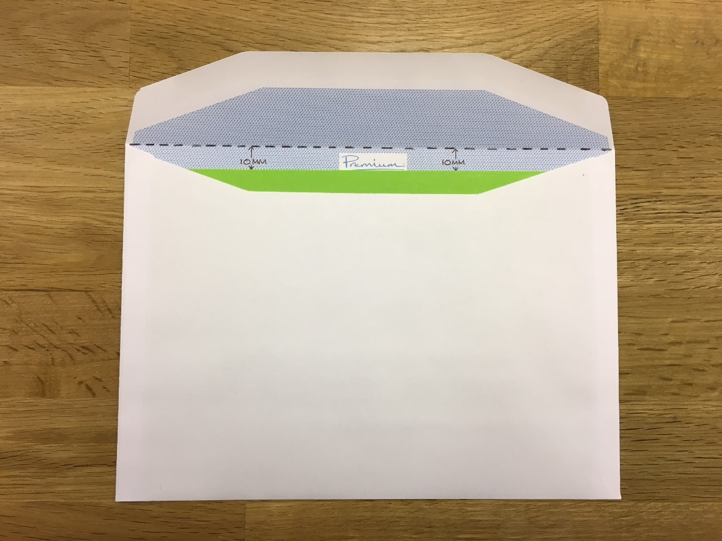
Fig 2.

VIII: PRINTED OR CLEAR POLYTHENE

- All supplied polythene must be a minimum of 25 microns, be of a low slip density and contain an anti-static additive.

- Reel specifications are as follows:

WIDTH (mm) WEIGHT (min-max)
250 – 380 25 – 30kgs
380 – 420 30 – 35kgs
420 – 600 35 – 40kgs

